PRIPREMNI DIO SATA
https://mail.google.com/mail/u/0/#search/tzk/QgrcJHrttjvhdDHXfCkBcQGvDbCnqXGvSrg?projector=1https://www.youtube.com/watch?v=8M9gsu3lYHc
GLAVNI A DIO SATA
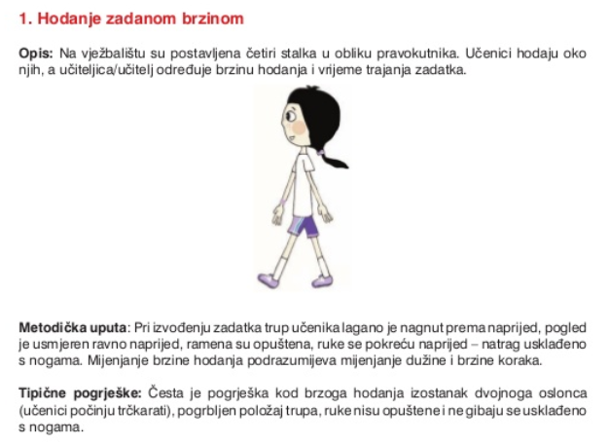

https://www.youtube.com/watch?v=MVwe-qNQjLs

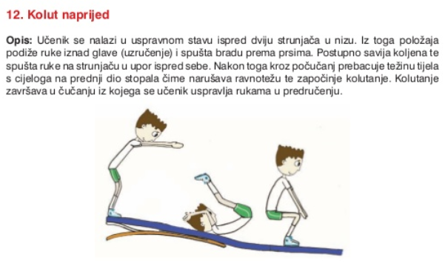

https://www.youtube.com/watch?v=iLNQ1-rGOnY

ZAVRŠNI DIO SATA:

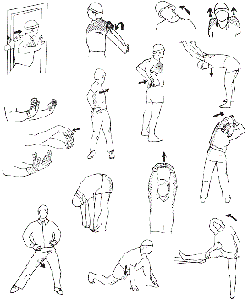
Vježbe istezanja sa slika radi polako i koliko možeš

