REVISION TEST
1. Put the correct word under the correct animal. Napiši odgovarajuće ime životinje ispod slike životinje.
Fox dog cat owl snake turtle
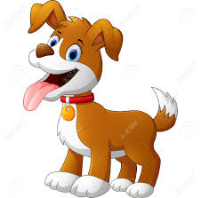 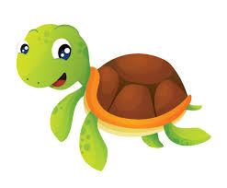 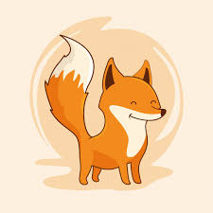
a.____________ b. _____________ c. ________________
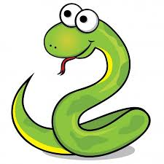 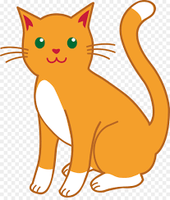 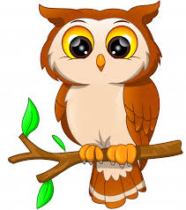
e.____________ f._____________ d. ______________

2. Put in, on or under. Ubaci u rečenicu in, on ili under.
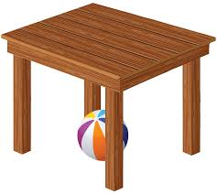 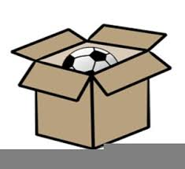
a. A ball is ____ a table. b. A ball is _____ a box. c. A girl is _____ a chair.
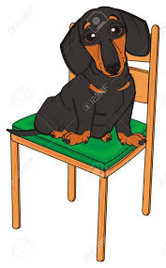 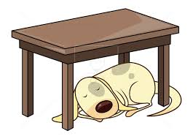
d. A dog is ___ a chair. e. A dog is _____ a box. f.A dog is _____ a table.
3. Put the correct sentences under correct pictures. Napiši odgovarajuću rečenicu ispod odgovarajuće slike.
It's summer. It's spring. It's winter. It's autumn.
It's raining. It's hot. It's sunny. It's cold.

   
   

