PID - Putujemo autobusom 13.5.2020.
- Prouči PPT prezentaciju
- Prouči sadržaje na linku: https://hr.izzi.digital/DOS/1109/1705.html https://www.e-sfera.hr/dodatni-digitalni-sadrzaji/32376dd1-3a9c-46c9-baa0-f74a4fd6b62a/
- Pogledati slike i proučiti u UDŽBENIKU 50., 51. str.
- NAPISATI NASLOV. ZALIJEPITI. RIJEŠITI u pisanke.
Putujemo autobusom
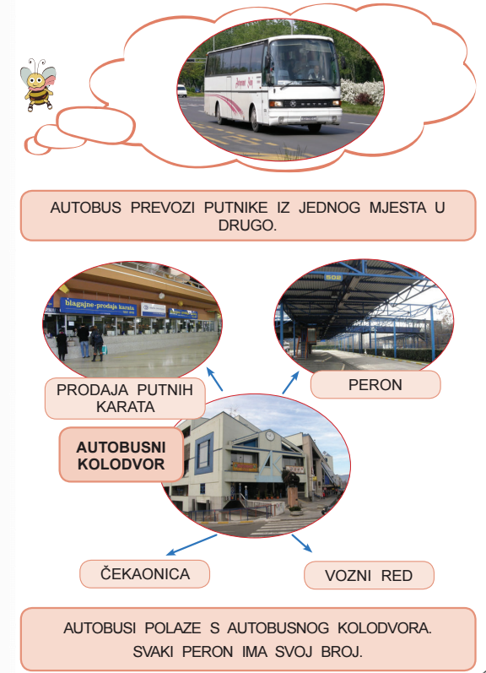

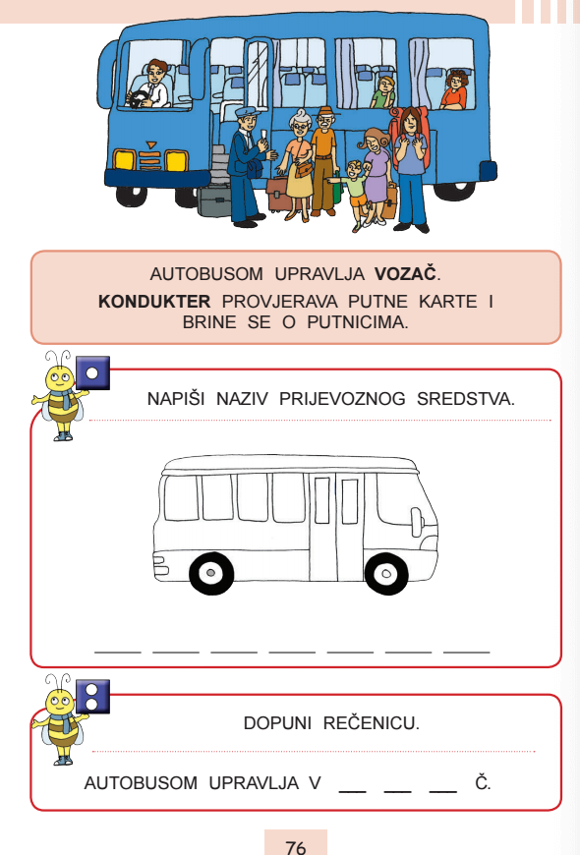

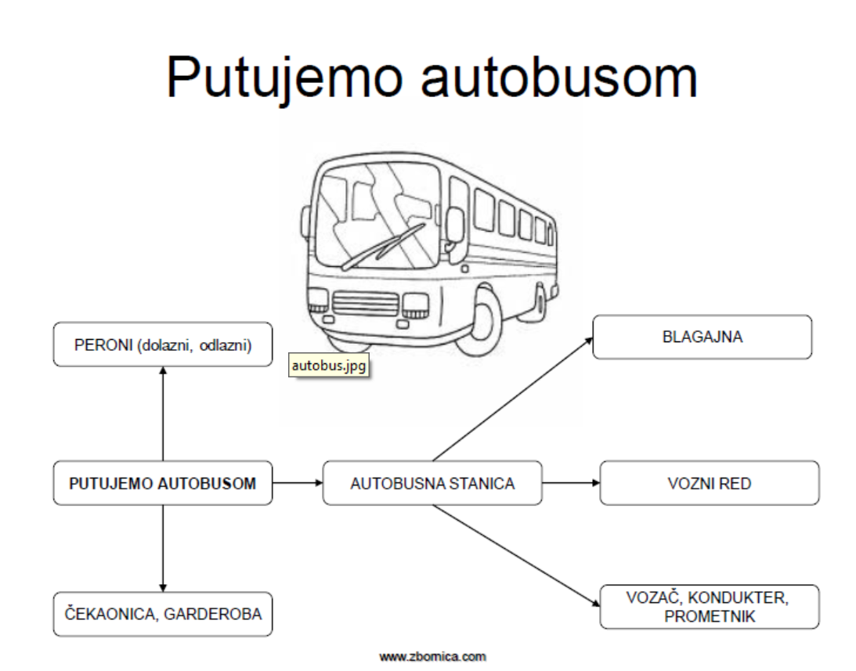

PONOVIMO
https://www.powtoon.com/online-presentation/fMrKOVF5PCf/?utm_medium=SocialShare&utm_campaign=copy%2Bshare%2Bby%2Bowner&utm_source=player-page-social-share&utm_content=fMrKOVF5PCf&utm_po=28404367&mode=movie&fbclid=IwAR1FAshsABjOZj6Tb9cEoMGADcstO4YsPb9lA45Y1XBuENr8x7ZL6-dz_Po
https://www.thinglink.com/scene/1313499371483955203?fbclid=IwAR2tWlNtIt2cSb_i1bF7d9-kjluSco8GOPGoKDBF81V8c6FFG22lenfrHmA

DZ – RB – str. 63., 64., 65.

